Name: **ZOHAIB HASSAN SOOMRO**

RollNo#: **19SW42**

Subject: **DBS**

1. Convert Following Data Base into De normalization form.

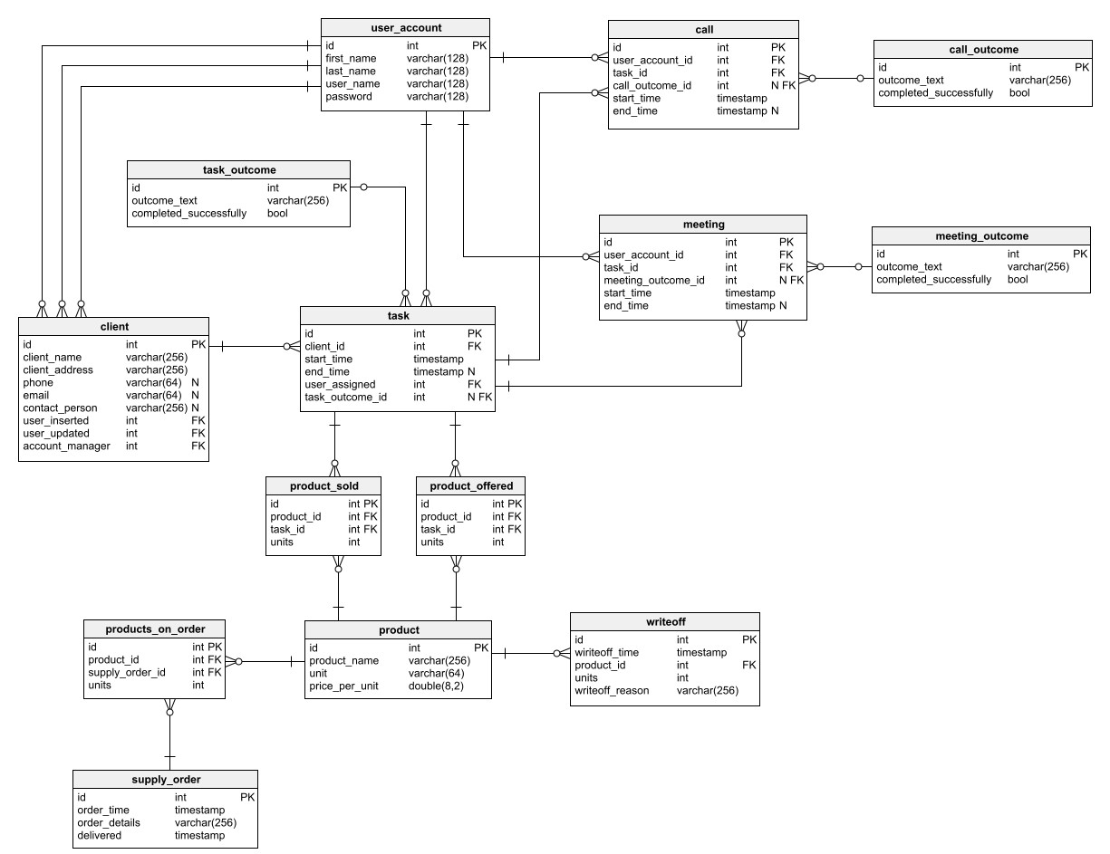

Normalized Form:

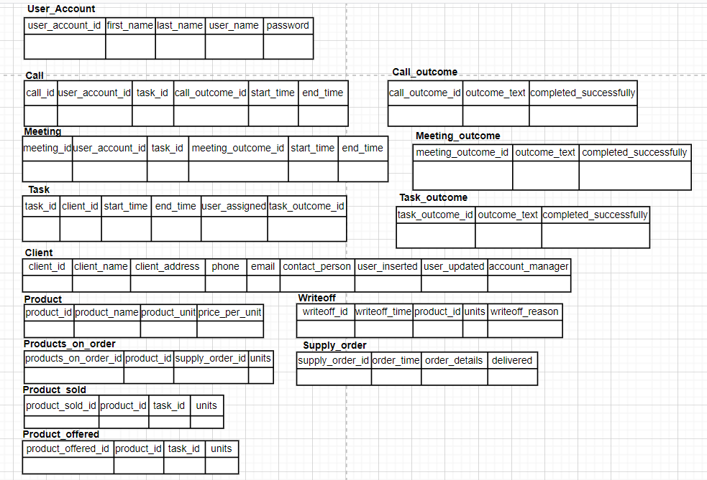

Denormalized Form:

